BREVET D’ÉTUDES PROFESSIONNELLES

SESSION 2008

ANGLAIS

TOUTES SPÉCIALITÉS

Durée : 1 heure

L’usage de la calculatrice et du dictionnaire n’est pas autorisé



5  10  15  20 | The New Forest National Park is going green, with visitors given a host of innovative incentives to leave their cars at home and take to the countryside on foot, bikes and even horseback, says Simon Heptinstall.  Squirrels, butterflies and grazing ponies are not in the slightest bit afraid of bikes. I can report this fact after a beautiful sunny day’s research pedalling through the woodland tracks in the lovely New Forest. I was experiencing a new type of day out in the New Forest.  I’d arrived by train at Brockenhurst station, collected a hired bike and rolled off on a traffic-free route through some of southern England’s best countryside. It was a complete adventure without my car.  It’s all thanks to a pioneering project by New Forest authorities to make England’s newest National Park into its greenest and cleanest destination.  This summer’s impressive eco-tourism campaign includes may hotels and Bed and Breakfasts offering “car-free” discounts if you arrive by train. Many still arrive by car, of course, but reducing traffic will improve the quality of the visit for everyone.  And over the years, the New Forest has remained a great area for car-free adventures, thanks to its network of paths and tracks. There are now more than 150 miles of off-road gravel tracks for safe family cycling and walking. And a 40 mph speed limit on roads has made it a calmer place to cycle and to protect the animals, which roam freely.  Cycle hire companies throughout the New Forest can supply maps, advice and bikes.  I found cycling the perfect way to explore the Forest in a peaceful, healthy and non-polluting way.

http://www.southwesttrains.co.uk (adapted)

TRAVAIL A FAIRE PAR LE CANDIDAT

COMPRÉHENSION

I. Cochez la réponse qui convient. | (1 point)

The text is an extract from | ❑ a magazine   a newspaper   a website

It is an article to promote | ❑ a transport museum   a national park   pony trekking

II. Complétez le tableau suivant. | (3 points)

Name of the park
Location
One activity
One animal
Nearest railway station
Speed limit in the park

III. Les affirmations suivantes sont-elles vraies (RIGHT) ou fausses (WRONG) ? Cochez la bonne case. Justifiez votre réponse en recopiant le passage du texte qui a guidé votre choix.
(6 points)

 |  | RIGHT | WRONG
1. | The New Forest’s priority is to incite people to come by car.  …………………………………………………………………………  ………………………………………………………………………… | ❑ | ❑
2. | Tourists riding their bicycles frighten the animals of the park.  …………………………………………………………………………  ………………………………………………………………………… | ❑ | ❑
3. | Simon drove to the park  …………………………………………………………………………  ………………………………………………………………………… | ❑ | ❑
4. | The New Forest is one of the oldest British National Parks.  …………………………………………………………………………  ………………………………………………………………………… | ❑ | ❑
5. | You can get a discount if you come by car.  …………………………………………………………………………  ………………………………………………………………………… | ❑ | ❑
6. | You can get a bike on the site to visit the place.  …………………………………………………………………………  ………………………………………………………………………… | ❑ | ❑

COMPÉTENCES LINGUISTIQUES

I. Complétez ce dialogue entre Simon Heptinstall et l’un de ses collègues : | (3 points)

- Hi, Simon.
- Hi, John.
- ………………………………………………………………………………. Last weekend?
- I went to the New Forest.
- …………………………………………………………………………………………………?
- No, by train.
- …………………………………………………………………………………………………?
- The train arrives every morning at 10.05.
- What is it like there?
- It is just great!

II. Simon raconte son weekend à son ami. Utilisez le superlatif des adjectifs proposés pour exprimer son enthousiasme :
(3 points)

Well, it was one of …………………………………….. (good) weekends in my life ! The site is …………………………………….. (nice) I’ve ever seen. The New Forest is ………………… …………………………. (peaceful) place I’ve ever been to.

EXPRESSION ÉCRITE

WELCOME TO |  | 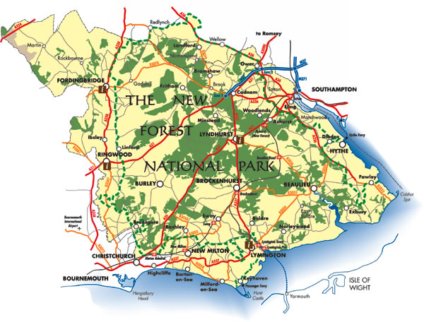
- Preserved countryside  - Beaches  - Comfortable hotels  - Bed and Breakfasts | 
 |  |  | What to see :  - Wildlife - great variety of animals : ponies, wild deer, cattle, lizards, toads, frogs, snakes…  - Castles, manors, museums, art galleries…
Sport and leisure activities  - Cycling  - Walking, rambling  - Golf | 
- Sailing, canoeing
- Waterskiing
- Restaurants, a traditional English pub, tea rooms

Vous venez de découvrir sur internet le parc “The New Forest”. Vous décidez de convaincre un(e) ami(e) de vous y accompagner. Rédigez EN ANGLAIS un paragraphe de 50 mots environ lui vantant l’intérêt du lieu et mentionnant les activités que vous pourriez y pratiquer
(4 points)

Vocabulary help ? - a host of innovative incentives : de nombreuses bonnes raisons
- tracks : des pistes
- hired : loué , de location
- paths : des chemins
- safe : sûr, sans danger

